Generale oaksncreates for servinceinnterfaces at sags- og dokumentwområdet

Younne standard are godkendt af OInO-komintea december 2009

>

General characteristics of serviceinterfa-ces of the case- and Document area
Published by:
IT & Telecom Agency

This standard can freely used by all. Quoted from the standard in other publications to the public, which Angie-fristede correctly kildehenvisning.

The standard is prepared by a working group Having The Reference Committee for case- and document the area.
Contact the OIO Committee: Project Rita Lützhøft
E-mail: rla@itst.dk.
Direct telephone: +45 3337 9242
Holsteinsgade 63
2100 Copenhagen Ø

Telephone: +45 3545 0000
Fax: +45 3545 0010

The publication is available on IT & Telecom Agency's website: http://www.itst.dk

>

Generelle egenskabare for seerviceinntearfaces på sags- ogdokuMentwområdet

The Reference Committee for case- and Document area

18th December 2009

Contents >

Purpose this document | 5
Background | 5
Genesis Process about standards | 6
Audience | 6
Reading Guide | 6
References | 7
Concepts and notation | 8
Notation | 9
Context and delineation | 10
Reference Architecture for case- and Document area | 10
Service Provider and Service Uses | 11
Service Interfaces | 13
Data Services | 13
Defending conditions | 14
Security and Rights | 14
Correlations between specifikationerne | 14
Action | 15
Document | 15
Organization | 15
Classification | 16
File Structures | 17
Relationship to other specifications and standards | 17
General properties | 18
Object | 18
ID | 19
Object Type | 19
Dual History | 19
Registration | 19
Life cycle | 20
Impact | 20
Attributes | 21
Object Name | 22
Modes | 22
Relationship | 22
Operations | 24
Hændelsessbesked | 27
Notifications | 28
User Control Models - examples | 28
Inspection Services / Service Description | 29
Annex 1: Overview relevant documents | 31
Annex 2: Structure of the standard-return message | 32
Annex 3: Structure of the specific incident message | 33

4

Introduction
>

Purpose with that document
The purpose of this paper is to describe the geneeeral transverse properties, applicable to all standards under the case and doku-ment area.

This document functions as a common reference framework for all standards under OIO committee for case and document.

This means that a number of terms, concepts and notation used in descriptions of the various standards are described in this document.

Background
The Reference Committee for Cases- and document the area was established in January 2009. The Committee is responsible for standardization of cases- And document the area within the state, regions and municipalities. Standardisation is aimed at all IT solutions requiring fos case and dokumentdannelse, ie. it is directed both against fagsystemer and ERMS Solutions.

The actual standardization work conducted by working groups established under OIO Committee.

The overall objective of standardization in OIOCommittee the case and dokumentomBoard is to support greater coherence and clearer division of labor between ERMS solutions and fagsystemer, and to create conditions for better and cheaper solutions in can better mål-informed authorities' needs.

Reference Architecture for case-and document area [ref. 1] is a centrally based on the standardization of the area.

Important principles of standardization:

Opdelinng in elementer . Der nedskintes selvstændinge piecenotdsgrupperom around each of the areas designated as central in referencearkitek-trip, that is. case, document, file, organization, group, party, labor and workflow management. In addition, areas that constantly had to be prioritized by the OIO Committee.

The individual working groups draw up a specification for each of their on-have that describes what the interface should be able to support the business needs for data exchange, including the eligibility requirements for Sammen-hænge derer tinl other froozethey omadviceer.

Interfaces must be used by the ERMS- and the fagsystemer to to exhibit oak-ne data and use others' data.

Breakdown in Part-elements processed by different but mutually-dependent of working means it has been necessary to ensure a close coordination across working groups with respect to choice of be-letter form and method. There is selected a method and a form to all groups must follow, including the decision on a number of gene-tural properties, which will apply for all standards under the case- and do-kumentområdet.

It These are the general characteristics and requirements for all the standards setbe-prescribed in this dokuments.

>

Genesis Process about standards
Reference architecture for case and document area (ERMS) was published October 2008.

Standardization in FESDauspices stopped by. 31th December 2008. The current FESD standards are valid until being replaced by new ones.

The Reference Committee for Cases- and document the area was constituted in January
2009th

The common public FRS for ERMS solutions were published
23rd March 2009 (revised version was published May 27, 2009) [Ref.
2]. Public authorities canao proceed to the own tendering future. Kravspecations are based on reference architecture and assumes that in 2009 established standards for case document archive structure; (upga-
vc) classification, organization and party.

It established working around case document archive structure, organization with participation of authorities and suppliers. There are average held six meetings in each working in period from February to September 2009. There is further work on draft classification in a small workgroup. There is 10 June held a joint across the groups. There is mid-June up a transverse arbejdsgrup-pe, to work with requirements / principles on how standards can be supported technically.

There have been a public pre-hearing conference 24 June with the aim to inform about the work and invite a broad public debate on draft standards, including involvement of relevant views for the completion of standards before sending in public consultation.

Based on responses received in the pre-hearing conference has reviewed the working draft standworking there.

Six draft standard is published in public hearing 12th sessionok. Tober to 13 november 2009th

The received responses are treated in working and it is her sub-decided what changes should be incorporated into standards.

The final draft standards are presented OIO Board to approval in mid-December 2009.

Audience
The target audience for the standards under OIO committee for case and document authorities, consultants and suppliers, purchasers need advice-giving on and provides IT solutions in some degree manage files and documents management and documentation of workflows and fos management.

The target population represents both a businesss- And the managementgramss insight and interest, and an IT and system knowledge and interest in both a strategic perspective and in an operational perspective.

Reading Guide
This document is structured according to the following structure:

6

>

To the startgsvis describes the purpose of this paper, background for stan-dardiseringsarbejdet on file and document the area targeted by document, used references and læsevejwire to the document.

InConceptsand the notation establishes the concepts used in this and related documents. This section is primarily thought as a reference.

In the sectionContext and the delineation describes the context for this and confirm slægtede documents. The following describes the coupling to referencearkitektu-clean, the interaction between service provider, service use and serviceinterfa-ce, a definition of data service and its role, and a description of the relationships between the various business services. This title can be forpart read by both authorities, consultants and suppliers.

In the sectionGeneral properties describes the general characteristics of business objects of all types. The following describes in particular the operations of individual objects may be subjected. The general characteristics are fun-damentet by individual standards are based. The sectionanbefales therefore read of both authorities, consultants and suppliers.

InAnnex 1 An overview of the documents prepared in connection with the case and document, including over the standards
is endorsed by the OIO Board and a reference to supplementary material for more guidance and other relevant standarder.

References
This document applies to several other documents listed below. [1] Reference Architecture for Cases- And Document area1.
[2] The Joint Public ERMS FRS, version 0.2 May 20092

[3] Unique identifiers for digital objects, IT and Telecom Agency, 6th De-cember 20063.
[4] Service Oriented Architecture What and why, IT and Telecom Agency4.

Below are listed a list of terms used relateen the general properties.

Specific terms related to each area (case, document, file, organization and group) are described in specification for each area.

1 www.itst.dk/fesd/referencearkitektur/version3.0
2 http://www.oes.dk/sw52231.asp

3 http://digitaliser.dk/resource/324032
4 http://www.itst.dk/arkitektur-og-standarder/arkitektur/serviceorienteret- architecture / SOA / more-about-SOA /

7

>

Concepts and notation

Conceptual Definition
Adaptor A mechanism for transformation of an interface to another interface.
Attribute Attribute is a session attribute with Impact, expressing an object's state.
Attribute Attribute is the smallest items of information in objects. They typically contain simple values such as text, dates, integers or Enumeration.
Description A textual explanation of the purpose and application that is complementary to other descriptions in sammenhÆn-gen. Subtotal explains all descriptions in a given context the whole relationship.
Designation A map and possibly complex expressions together-sets description and is unique in consistency.
Terms A set of conditions to be met to grant, modify or delete attributes, conditions, or relationships or to conduct operations.
Dual History Properties of expression data over time in a registered design and effect perspective
Enumeration A finite number of each unique textual beteg-term courses, each of which specifies a unique value.
Business Object See Object. Business Service See Service.
ID Identification, see also UUID.
Generalization A collection of properties that are similar to several of the ob-jekttyper. See also Specialization.
Interface See Service Interface. Interface See Service Interface.
Cardinality A expression for the number of relationships that must be created between a business object and foreign objects.
Object A object defined by the justifies a looklv-alone service. Objects contain attributes to-stands and relationships other objects.
Operation An action or proceeding that creates a well defined law result from one or more input parameters
Parameter Input to or output operations, typically messages containing objects.
Reference Referral another object through the declaration of the object UUID.
Relationships A collection of references to related notes. Sam-ment is limited by a cardinality.
Services Services are an abstraction over forretningsfunktionali-ing and information made available for look-viceanvendere via a published viewrDeputy contract [Ref. 4].
Service Uses Serviceanvendere are systems that receive, Applicationen-there and submit business objects through ser-vice interfaces. Service Usesuses servicein the interface.

8

>

Conceptual Definition
Service Interface Interface between a service uses and a ser-vice provider.
Service Provider Service providers are systems that receive, storage suppliers and supply and liabilities and importing for-direction objects of specific types through service interfaces. Service Providersmounts serviceinterfa-ces and exhibits its operations through an interface.

Specialization A collection of properties that are unique to a be-voted object type. See also Generalization.
Specification The specification is the service's external representation is realized in serviceimplementationen [ref. 4].
Condition Modes are information elements objects, corresponding to attributes, but for which it applies, the res-values can only belong to a finite number (enume-rations) and the value shift should depend provisions tea patterns (state tables).
UUID Universal Unique Identification of business objects. Values A description of the values that attributes tilstan-
they and relatives must take. Examples are texts of
a specific length, dates of a certain interval, hel-numbers in a certain range, Enumeration and relationships
to a particular object type with a specific kardinalin-
Tet.
Table 1

Notation
It noted that it generally tabulation are chosen to placebe-letter on the far left and heading to the far right. This is done to highlight and support the focus on the semantic content and the defini-toric rather than name, which alone can be perceived as a short form and label.

9

Kontekst and delineation

>

Reference Architecture for case- and document areaReference architecture for case-and Document area5 is the starting point and framework for work on the specification of standard interfaces under OIO-Committee for case- and document the area.

The reference architecture identifies a number of necessary and desirable fos-direction services6, as illustrated in figure below, which is needed when one wants to work with files and documents, whether there is an ERMS solution or a fagsystem.

Reference architecture is thus a means of making demands for theyinn the interface offered by the case, document and archive and to the interfaces that case, document and archive needs. The functionality will be expanded as the need arises.

It is a benchmark for Reference Architecture that the identified business services by 2015 may be supported partially or completely comepo components with service interfaces through the use of common public OIO standards.

The goal of standardization in OIOCommittee for the case anddo-kumentområdet is to realize and translate ANBemendations from referencear-chitecture in a series of joint public OIO standardized interfaces that can support a more flexible interaction between ERMS and fagsystemer.

5 www.itst.dk/fesd/referencearkitektur/version3.0
6 A business service is a logic function which is an essential part of the business itself or made disposal of business (eg. Book holderi). Every service is described with a logical interface. A servicebe-letter says nothing of how it performed. It can bema-nuelt, half-automatically or automatically, when automatic leveres of IT systems.

10

>

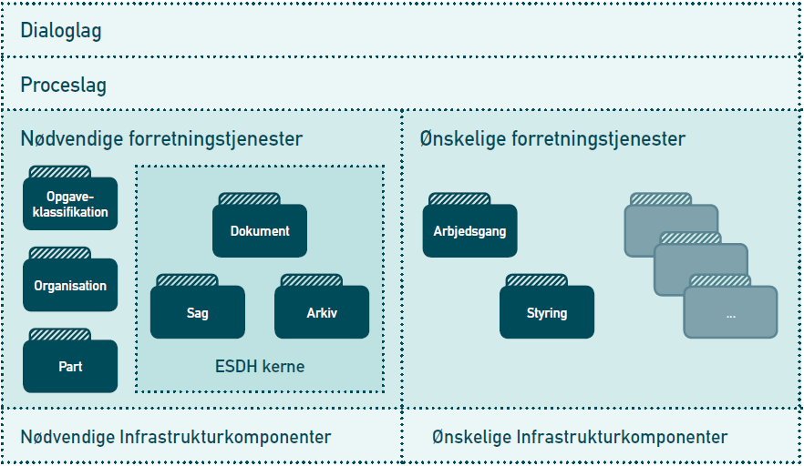
Figure 1 Necessary and the desirable business services

The figure contains a generic layered application model, consisting ofla-general: Dialogue, process, business services and infrastructure.

A more accurate term for the components of business layer is Forret-test services. It is this concept that will be used in furtherbe-letter.

A business is defined in this context as a whole or del-degree of automation of activities in a business service that is accessed through an interface or an integration, and can be controlled by a MICRo- Or macroflow in process layer. A business provides an interface that offers some operations targeted to store, locate or retrieve data through a series parameters as described in a specification model.

The interface can be implemented on new or existing intSolutions. So there are not a description of the implementation model or whenta model for the system. There will typically be a transformation between inter-facets model specification and the concrete implementation model. Internacionalfa-cet can be implemented in whole or in part, and could add additional functionality. This is clearer in section Serviceinspekti-on / Service Description late document.

Service Provider and Service Uses
Service providers are systems that receive, store and deliver all liabilities and import business objects of specific types through serviceinterfaces. Service Providersmounts service interfaces.

Serviceanvendere are systems that receive, use and hands-on direction objects through service interfaces. Serviceanvendereusesservice interfaces.

11

>

Systems typically act as either service or serviceanvendere, but can also be both service providers and serviceanvendere. This illu-tered in Figure 2

For example, an ESDH-system service provider of business objects and Action Document, while a fagsystem service is used by businesss- Objects and Action Document. Fagsystemet may themselves also be ser-vice provider of business objects and Action Document. This is incidentaldone when ERMS system handles the general case and document properties, while fagsystemet handle the discipline-specific case and documentt- Properties.

Other
Serviceanven there

Fagsystem

Dialog

Process
Sa g

Data Access
D o k

ERMS- system

Dialog

Process
Sa g

Data Access
D o k

Figure 2 Systems as both Service Provider and the service uses

In Figure 2 fagsystemet act both asServiceuses, since it customer documentst- And file services from ERMS system and as serviceproviderBecause it offers document and file services to other service uses.
A Second use scenario serviceinterfacene is connection with a co-menstilling of central key information from many different systems in a portal (eg. all relevant information about a child a local pam-menstillingsløsning). Here a series fagsystemer, each han-ing different types of cases and documents, act service for a matching entry, while acting service uses one or more central ERMS systems. Such a solution would specific case and do-kumentoplysninger be stored in each of fagsystemerne while the ge-

12

>

above the general case and document information would be forwarded to and storage right central ERMS systems.

Service Interfaces
Service Interfaces can be installed on existing systems (service-enabling) or embedded in newsIT systems. Behind the interface there may foreta-Ges a transformation between the internal implementation and the abilityar-diserede specification. This allows the creation of reusable and interoperability between systems.

Service Interfaces are the system interfaces in Unlike user interface. This means that the names used in specifications, only exchanged between and interpreted systems. Choice of names must be unambiguous and understandable support the exchange of data, but need not necessarily match the names used in usees interfaces and read by end users. For the same reason focuses hayje-re density of the elements properties and value the role rather than names.

The specification for each service interface describing the properties of the object on display through serviceinterface, but handled in the underlying systems, including ESDH- And / or fagsystemer. This specification describes the general characteristics of each stateaR is based.

Data Services
The here specified service interfaces exhibit alone operations data-access (ie receiving, storing and supplying data objects), even services that deploy these service interfaces may contain a much greater functionality.

EndsAction for instance, is a process in service's proceslag because itnd-meddle handling of context-specific business rules that can not be inferred and interpreted from the data layer only, and is thus not an operation in the service interface Aid linked to Action object. The corresponding operation
the data service layer isRight case som sÆtter tilableen tinl afsluttet .

Existing ERMS- and fagsystemer which day offers a much richer funktionalitet than just data access, including their own process and dialogue can usefully mount service interfaces in order to act as document and file containers for other systems.

Service interfaces can also reduce the possibility of working with televisionÆr-cutting processes by providing data to available from the Involverede systems through these interfaces.

Example: A reporting system on which documents must make do-inary document available for ERMS systems by reporting system operates service provider by mounting interfaceDocument.
If the ERMS-system must store the documents, they will be imported via the interfaceDocument on ESDHSystem, which operates customer service.

Process between service provider and service customer can be handled in many different ways (synchronous / asynchronous, push / pull, automa-matic / manual) and with different communicationsprotocols.

13

>

Defence of conditions
Services defends the business rules associated with business objects.

Data Services defends the part of business rules associated with da-taintegritet. These business rules are called conditions and include the pre-releases (Preconditions), which defends the service within the store. If the condition is not met, there will be an error message.

Conditions that goes beyond data integrity rules are not handled in da-taservices but of service use are typically in process layer. The specific conditions set out in the individual specifications.

Security and rights
Service Interface Specifications must be installed on existing systems and the new systems or components. Serviceinterfacespecifikati-tions must therefore be subject to the security properties that these systems possess.

The fundamental characteristic that all implementations of interfacespe-cations must possess is that they must defend the object's integrity and confidentiality ie. that objects must not be modified or displayed util-sighted.

If interface used by an existing ESDHSystem interface can be subject to the user-rights management, as this system has im-plements.

If the interface used in a context where security is implementingen-found at process level, it is this security model that must be respected-res.

If the interface is mounted on a separate component, the security may be implemented through the Danish profile of SAML 2.0.

In afsninttet BryeerstyrinNGSmodeller examples wereler sindst intime to timeste CHAPTERSintel ginves examples of various user-right models that could use des in connection with implementation of interface specifications.

Contexts between specifications
The breakdown in business services is justified a strategic desire to create smaller systems without duplication of functionality and built to inn-tegration.

The various specifications are interdependent, as described
in below. There are relationships between them by their objectsrE-tions to each other called object references.

It is not assumed that a given company has only one implementation of a service interface. If there are multiple interfaces, which handle the same types of objects that are needed for the organization has a global view (in catalog form of UDDI electricity) over the various business services. This is not solved with national specifications.

14

>

Each specification håhandle the one or more object types and references to other object types.

Action
Service provider interface following object types and relationships.

Description Object Type

A collection of related documents and other connected information in her entire used to document a process, typically for administrative purposes, including making decisions.

Action

Relationship Object Type

Document handling the files Document

File Structure, which handles the files as files tinl-linked
Archives

Partners who handle litigants Partners

Classification handlers proceedings classification scheme
Class

Organization that handles file players Actor
Table 2

Document
Service provider interface following types of objects and relationships.

Description Object Type

Documents composed of distinct collections of informationti-tions, in known structures of known formats. Documents can contain text, drawings, graphics, photographs, video, voice and / or much else.

Document

Relationship Object Type

Organization that handles document players Actor
Partners who handle document parties Partners

Classification, which handle the document classificationti-onssystematics
Class

Case handling the cases for which the documents included in Action

File Structure, which handles the files as documenter-ne attached
Archives

Table 3

Organization
Service provider interface following object types and relationships. Objekt types in organinsetinOn kaldes underet Aktør .

Description Object Type

Organization is the only legal organization (legal entity). It can be an authority (Ministry of Governanceel-se, cowmmune, ) generalren vinrksomhed (Med; cvr-number).

Organization

15

>

Description Object Type

An organization unit may be attached to an organization directly, indirectly or not at all. Such a device may be a department, section, office, committee, project team, steeringre-group, class, teams and the like.
An organizational unit can be used as a generic term for an organizational view into the organization.
IT systems or configuration items, as in the re-levant registering anything on the organization.
Begrebet bodyinSatorinsk funktinOn Applicationendes onen funKTI-on or role the actor has compared to theyøOther items players.

User is an actor type that represents a useriden tity including a certificate. It may be a person or an IT system which operates using.
Interests are perceiving as a named co-opment of people, not a legal entity. Thus reserveres begrebet bodyinsetinon tinlen forMel bodyinSati-on. But otherwise a shared interest could have sam-me performance as an organization.

Organization Unit (OrgEnhed)

IT system

Organizational function (OrgFunktion) User

Interest Community

Relationship Object Type

Classification, which handles its business, up-gifts, authority type, device type IT system type user-gertype

Class

Table 4

Det bemærkes to objeKTTypen Bruger inndgår as reference in alle the stated, moreover-ge specifications, because it is the actor that is used when one detects objects.

Classification
Service provider interface following object types and relationships.

Description Object Type

Here attached information, which together describe the various systems used for classification. Should such be accessed from the Archives, since Archive refers to classificationti-onssystem.
This describes each facet (dimension) included in classificationssystem. It contains information on building in lists hierarchy, etc..
Class includes practical classes. These classes can be ordered hierarchically and therefore have over-and underem-tions. Classes can also also have contiguous classes (references), also called related classes. Must be able to be accessed eg in the markup of files and objectively States.

Classification

Facet

Class

16

>

Relationship Object Type

Specifies the organizational actor who owns, is the editor or responsible for the classification objects
The reference to other classification systems classes (map-test)

Actor

Class

Table 5

In addition, the classification used in many other contexts, for example. to to accommodate other classification systems than those traditionally used for file and document area.

Archive Structure
Specification File Structure used to to get an overview of the proposed emergence of archive each organization / authority applies. File Structure to be used by the specifications and Action Document to to describe the which file to their business objects are located, hence the common characteristics of such a collection of files and documents in relation to archive period, delivery, cancellation, etc..

Service provider interface following object types and relationships. Description Object Type

A archive contains material classified by one and the same classification system.

Archives

Relationship Object Type

Classification to indicate the systematics archive føl-ing
Organization to identify the roles various actors can have in compared to archive, for example. who has responsibility for the records

Classification

Actor

Table 6

Consistency to other specifications and standards
The following standards are relevant compared to standards under the Interoperability Framework Committee for case and document:

Conceptual Model for user management
Recommendation to a general event message
The next standard, which is scheduled standardized auspices of OIOCommittee for case and document are:

working party (CPR)
There is also a concern that the general characteristics can alsoan-turn at address, authority, business (CVR), a source of law, etc.. These
registers do not have the general properties are reviewed in the føl-
ing. Until this is in place, used the keys to these records-pose. From the individual specifications.

17

General properties
>

In the following describes the general characteristics that apply for all ser-vice interface specifications.

The figure below shows the main elements of an object.

Objects are characterized by being composed of attributes, forwardingtduck and relationships other objects.

Attributes, condition and relation can change value over time indicating element effect.

Objects handled by operations. Once a user has performed an operation that affects an object, formed a registerrproximation.

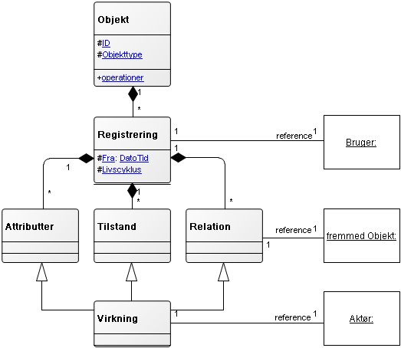

Figure 3

The elements elaborated below.

Object
A object has a unique identification and are of a particular type.

Description Values Obl Designation

Immutable, information and solve university fied motor vehicle unique identifiers of an object

UUID Yes ID

Object Type Object Type Yes Object Type
Table 7

18

>

ID
ID contains objects identification.

Object Identification must comply with the standard for the identification of digital objects (Ref.3). This means, among second, that identification is incompatiblean-ly, informationsløs universal and unique.

Objekters ID er begrÆnses derfor of vÆrdinskintet UUID.

Unchangeable means that identification ensures technical identification of DA projects throughout their life, even when they are distributed in Unlikeli-ge services in which they are imported.

Informationsløs means that the identification does not contain information and thereby remain unchangeable.

Universal unique means that identification can not occur more than once, either in same instance of a service or across multiple bodies set-looks the same or different services, nor over time.

Conditions:

ID must be assigned value when creating the object. ID can never change the value after creation.
Object Type
Object type is a type name for the object.

Specifications defines the following object types: Action, Document, Archive, Agency, OrgEnhed, OrgFunktion, IT system User Interest Community, Classification, Facet, Class.

In addition, relationships with objects not yet defined: Part, address, email address expenses etc.

Dual History
The characteristics of dual history puts service uses in able toan-view and treat objects two independent time perspectives, called the registration and effect.

Registration perspective indicates the time oftis where the whole object with its attributes, conditions and relationships are registered.

Registration
At every operation that modifies objects, attributes, conditions or relatedino-bonds (Create, Import, Right, Passive, and Delete), create an object registration. Dins-watch operations, except maintenance work on a copy of the originalob-jektregistrering.

To manage objects registration periods used an item with the following fields:

Description Values Designation

Date and Time for registration. Datetime From

Object technical momentum compared to eksi-stone.
The object is created. Added
The object is imported. Imported
Life cycle

19

>

The object is passivated. Passivated
The object is deleted. Deleted

Referral the actor who made registration ring.
UUID Actor

Table 8

Element attached to object its entirety. At each registration created a new Object Relation above structure. It may not be possible to modify the an earlier registration. The purpose of registration is to be able to do-inary document the contents of an object at any time.

This feature can be implemented in traditional log or in a database, depending on the object's character and business needs, for example. to able to document calculations, both the data entered into the calculations and the result as a calculation is achieved rather to.

Life cycle
Field Life Cycle contains information about objects creation and control. The object is controlled by the service being created, imported, passinvc-right or deleted object.

Created and imported objects can still be changed. Passive nest and deleted items can not be changed. Deleted objects correspond to lo-cally deleted items. It is possible to import a passive object again.

Conditions:
Life cycle changed mode of operations in the respective services. It is however this context appropriate to illustrate the fore-
next cycle modes and mode switching.

class Domain Objects

Opre ttet Slettet(land theinsk)

Pas sinv Inmpor teret
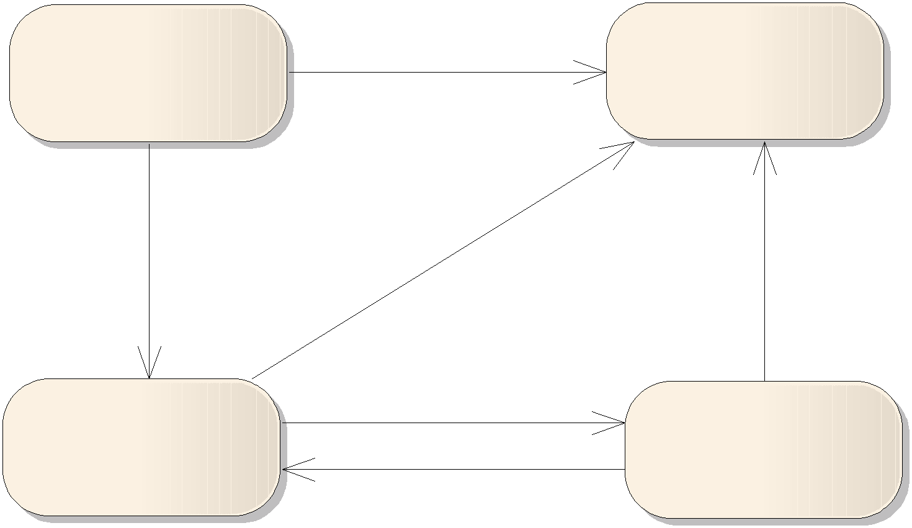

Effect
Figure 4

Effect perspective indicates the time periods in the values of objectively States attributes, conditions and relationships have effect.

20

>

For example, an object of type document have an attribute field that be-signed as title and title attribute are in attribute dokumente genska-ber.Indholdet of this attribute may change over time.

Changes can be made both in the time and back in time. Time period indicated typically by the operator who uses businesssservice but may at their exclusion, are replaced by default values.

Time periods may be subject to temporal gaps, but may not have temporal overlap, as such creates ambiguity. Timing holes, by contrast, shows a lack of knowledge in these periods and there-with an acceptable degree.

To manage objects effect periods used an item with the following fields:

Description Values Designation

Starting date and time the impact period. Datetime From
Final date and time the impact period. Datetime To

The reference to the actor who causes iværk-translation effect of the period.
Any notice, identifying the reason for iværk-set of the relevant impact period.
Table 7
UUID Actor

Text Note

Element attached to object's attributes (not each) to each object's modes and the to each object's relationships.

Objects built from several sets attributes, several states and several relatedino-tions as the objects change over time. After each adding a new set of attributes, conditions and / or relationships, and above the toe-the structure. Objects that have undergone many changes over time inn-therefore they comprise multiple sets of attributes, conditions and relationships than the objects which have undergone little change.

Hasman inkke behey for vinRKNinng,seasonal workttes From tenl uendeling and the Tinl tinl
+ Uendelig .

Attributes
Attributes is a collection of attribute fields. Attribute can, for example, hold the titles of cases or letter dates on documents.

Objects of different object types have different attributes.

Attribute is constrained by values, including texts, dates, numbers, objekT-types and others. This means that attributes can only assume values that are described in the their respective values as specified in each specialty; ci-cation.

Attributes and their attribute fields can be further limited by conditions that govern how they each have assigned values.
Attributes may change value over time indicating element effect. Objects have at least one attribute with the following attributes:

21

>

Description Values Obl Designation

User Facing textual identification of object-ing.
Object Name may have a different name for the document, for example. title.
The period during which the value of the attribute Gael who

Text Yes Object Name

Effect Yes Effect

Table 8

Object Name
Object Name attribute contains objects user-facing identification. Object Name may have a different name in the various specifikationer but attribute has the same properties (mandatory).

Modes
Mode represents the object status. Mode put depending Forret-tion-related context and be actively pursued by the actor. For example, a classification be published or unpublished, and an organization may be active or inert.
Each specification indicates which states the object can be in. Modes can change value over time with the use of the element effect.
Operator is in this context, the actor who causes change of state. The note can be used for to justify the status changed.

Conditions may be attached to conditions that govern how they can allocation, les values. For example describes a state requirement that a file can only be brinnges in stateus NotidelseGocomeNDT , Hvins det tindlingere have været in stock Anmeldt .

Relationship
An object will have multiple relationships one for each reference to anotherob-ject. Relational using the item impact, and thus there may be tinl knysaturated a note to each reference. The references stored with the object7.

For example, relates a case to an archive proceedings are in. This il-illustrated from Figure 3 If the case file switches at a given time will cause a new instance of Relation with a new period and with re-fe-petition to the new archive.

7 See Concepts and notation for a deepening of the gap betweenlem reference and relatinon .

22

>

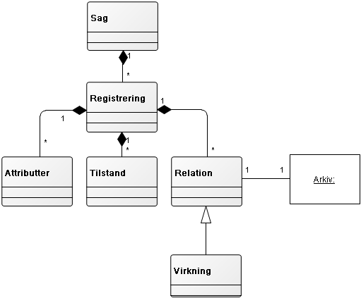

Figure 5

In the example, the object reference to Case Archive, but the Archives has not der-with reference to Action.

The relationship can only relate objects of specific types and only specific number, delimited by an interval. If a relationship for example is limited by object type Actor with cardinality 0th 0.1, so the relationship can only refer ac-tors and never more than one at a time same period.

Relationship is further limited by conditions that govern how they must be given references. For example describes a related condition, that issue can not be assigned additional documents after the case is brought in tinL-stand Afsluttet .

Relationships are modeled with this structure to make way for impact, impact player and note that it is also prepared in order to add references to new object types which over time need arises.

The relationship between object types allows for bulk coupling betweenob projects from a second specification. At the time when the relationship is formed, it is assumed that the right ID, which is added as a reference,findes. But when the reference is formed, there is no guarantee that the object not later modified or deleted in the foreign service.

To compensate for the lack of reference integrity must delete selected objects and communicate this with ahændelsesbesked. Furthermore, the object as far as possible to refer to another object as stedfortræ-there.
Certain items must be physically removed from service under different rules, and the controller must ensure that this is also observed. Used detection perspective (see later), you will find the original object as it looked on a given recording time, and can therefore use it as evidence.

23

>

If the organization does not have access to a specification related objekT-types can be compensated for with a proxy (proxy).

If, for example. transposedclassification, but notorganization, one must compensate for that lack of reference to actor. This can be done by the delegate provides an ID, as folderstil organisationssy the system you are using. The same applies if one wishes to usean-less relationships foreign objects that do not yet have those properties. The rationale for this is that unique device (UUID) for identification was a for-requisite for interoperability. When we later implement organizationaltin-on, vinlman kunneimportere the ID er, man allerethey have benewttet.

In principle the relationship only contains reference to the second object. In practice, you will need to save information so that do not have to beat them up every time it shows the objects. Eg. will be a reference to a class in a classification system consist of UUID for the object. This must be informationsløs and therefore will be in practices need to save for example. klasseidentifikator and a name. There is therefore a temper the same time memory (cache), which will be updated at intervals eg. based event messages.

Operations
Objects handled by the following operations:

Description | Input | Output | parameters | Designation
Creates a new | Object Create | Object |  | Create
Object |  | Standard Return
Importing an ob- | Object Import | Object |  | Import
ject |  | Standard Return
Finder and return- | ObjektID | Object | VirkTid | Read
bine object |  | Standard Return
(Always latest re-
gistrering)
Corrects an object | ObjektRet | Object |  | Right
(Always latest re- |  | Standard Return
gistrering)
Deletes (logical) one | ObjektID | Object |  | Delete
Object |  | Standard Return
(Always latest re-
gistrering)
Liabilities an ob- | ObjektID | Object |  | Liabilities
ject |  | Standard Return
(Always latest re-
gistrering)
Finder and return | Search Criteria | IDListe | VirkTid | Search
bine several objective- |  | Standard Return | RegTid
ter is matched
RER search criteria
Finder and return | IDListe | Object List | VirkTid | List
bine several objective- |  | Standard Return | RegTid
ter is matched
suppliers IDListe.
Table 11

24

>

Inputs
Input contains a structure with an object, its parts or search criteria. The structure of the input message is defined as an annex to each spe-
specification and can be different versions.

Output
If the operation is completed, contains the output of a structure with the result of the operation. The structure of OutputCommunication defined as
Annex to each specification and can be different versions.

Standard Return
Standard Returns contain the return codes in form of information, warnings and error communicatingelser, and Standard Returns are always included as output, because the inside
provides information on whether the operation is completed or not, hereun-
if used default values. The structure of StandardRetur- Notice shall be annexed to the general characteristics and will be common to all specifications.

Parameters
Parameters are really into input structure, but it will not be any implementations which can work with these parameters. VirkTid and RegTid
may contain blank, a date or a timesperiod. If RegTid is blank, get the latest registration. If VirkTid is blank, an attempt at all
effect periods.

Sign up
The operation creates a new object from the input structure.
Input must meet the conditions for the object's attributes tilstanthey and the relationships-tions cf. service interface specification for each object type, or else given an error message.
The service responsibility to assign ID, provide a registration livscyklus-tilable Upstandet samt udfylthe defaulTVærdiur. Objektet in sinn whole return
retrieve the output.

Import
The operation creates a new object on the basis of inputs in the same manner as maintenance, but with the difference that the object ID must be included in input. The foR
direction rationale for the import operation is that an object must be found in various services with content that is updated asynchronously.

Input must meet the conditions for the object's attributes, conditions and relationships-tions cf. service interface specification for each object type, otherwise returns an error message.

If the object is found in advance in the service is given a fejlmed-NOTICE, otherwise service shall constitute a registration cycle mode Inmporteret samt outfylthe deFAUltsignifirdiur andreturnereObjektet in outputt.

Read
Operation takes an object from the input structure ObjektID, which contains only ID.

25

>

If the object does not exist in the service, given an error communicatingel-see. The service responsibility to return the most recent registration of Objek-ing.

If the parameter VirkTid specified, the object elements will be filtered so that only those elements that have impact on VirkTid, is returned. If no elements have effects on VirkTid, give notice.

Right
The operation notify an existing object. Formed a new recording of the object.

If the object does not exist in the service, given an error informantel-see. Output must meet the conditions for the object's attributes, modes and relations cf. service interface specification for each object type, otherwise returns an error message.

Input must contain the ID and the elements that must change. Unchanged elements and lists of items need not be included in ObjektRet but it gives no errors.

If the contents of a list of items addressed, the entire new list of ele-menter into ObjektRet.

If ObjektRet is empty or contains the same elements as the watchnE-first recording, produced no new registration and gives a return code of warning.

The service responsibility to return the new registration of object.

Delete
The operation forms a new recording of Object ObjektID with lifecy-klustilable Slettet . Den Forraninngsmaessinge bebecauseelsee for slet
operation is to allow for (logical) to remove objects that can
no more need.

If the object does not exist in the service, given an error communicatingel-se, otherwise the service return the new registration of object.

Liabilities
The operation forms a new recording of Object ObjektID with lifecy-klustilable Passinv . Den Forraninngsmaessinge bebasic lodging for passive
operation is to distinguish between (logical) deleted and passive Objek
ter. A passive object can still be used, but not maintained.

If the object does not exist in the service, given an error communicatingel-se, otherwise the service return the new registration of object.

Search
The operation returns a list of identifiers (IDListe) based on a search criteria. Can be formed in many different search criteria structures.
Common to them is that they are working on all objects in service and all registrations of objects.

26

>

The criteria can be specified for the whole object or selected elements ofob project. That is both structured and free text search can be supported.
You can filter the registration dates and efficacydatoer there be included with the parameters RegTid and VirkTid.
If no objects match the search criterion, given an information.
If multiple objects satisfy the search criterion, than the service can handle, given a warning.

The service responsibility to return a IDListe with Objects.

List
The operation returns a list of objects specified in IDListe. There may be many prædefinCombined Object List structures. There can be linked
sorting and segregation in the pages of lists.

IDListe ID must contain at least one Object otherwise returns an error. IDListe will typically be output from a search.

You can filter the registration dates and effective dates to be included with the parameters RegTid and VirkTid. If RegTid not specified, the search for recent records. If VirkTid not specified, searched all impact periods.

The service responsibility to return an Object List.

Event Messages must be restored by performing a search and a list of changes to the attributes, conditions and relationships.

Hændelsessbesked
There shall be formed a specific event message each time an object changed. The format of this message shall be annexed to each list.

The specific event message associated with a general event message, which applies to all event messages and functions as envelope. The ge-necultural event message contains information use for handling the messages in incident distributers and described in detail in Recommendations for a general event message.8

The specific hændelsesbeskeds general characteristics described here.
When a business object life cycle changes (see below) or there is changes in object's attribute, condition or relations must form a
specific event message.

Event Message must indicate the object's identification and its object type, time of change and sufficient information for a subscription expression eg. related to classification and organi-

8

http://digitaliser.dk/resource/431101/artefact/Anbefaling_generel_h% c3%
a6ndelsesbesked.pdf

27

>

tion operator. It is not intended that the whole object will be sent with the event message.

If a subscriber wants more information than event message indE-holder, the subscriber may disable the object into the service. The rationale for this is that different viewers will need different information, and will have different rights in compared to object. This means that it is a balance to weigh the strength of Event message mel-tween the necessary and the right sound. Therefore it would also be up to a contractual relationship between service and incidentsbenefits-clean to decide who will be able to subscribe to a particular type, including at what times, incident messages posted.

Example
Planned an organizational change with effect until the time, and you do not want the affected learning of them before organisationsæn-invitation comes into force. It should therefore be possible to restrict access to these event messages through subscription expression that includes the stand and effect.

Timing Modes understood as the state changes due to time passes handled by the generation mode with a future effectsgs-time. This future state of change must be included in a hÆn-delsesbesked. When the specified time effect occurs, is the object in the described condition, without you have made a new registration.

Example
If you have sent a document in consultation and the document is to be regarded as approved if no objections are raised within a certain time point, we can provide state of the specified time. If there bli-ver objected, you can change the mode or remove it.

When you deploy a service interface specification must therefore make a deal with an incident breaks that may receive Eventbe-scabbards related to the service objects. It is through incident manifold that different parties can subscribe to event messages and initiate a workflow on that basis.
Subscription and event manifold is not a part of this specificationti-on.

Notifications
If you want to put an object in memory to get an advance notice at any given time, you must create an event message, without the object needed, speakingen-sarily have been changed. This event message must have a future effective date and the person who must be warned, must subscribeere
the event message.

User Control Models - Examples
This section contains examples of how to build RETTing-speed control for access to the objects that the service handles. The actual management and enforcement is not part of the specififikationerne.

28

>

A user management rights are defined by an action on an object.9
Rights brought together in user management roles. In this context, the early-re said transactions conform to acts.

The question is how to define the ellare the objects that must be covered by user management right. There is of course possible
to delineate in compared to different object types, but other information will be used for delimitation.

One possibility is to use a relation to a organizational actor eg. to the actor that owns the object. This can be done from user managementsrules that could include organizational structure.

Another option is to use a relation to a classification system, der rummer sinkkerhedsmaerker inet hiurarkin. As neededer sheepmanen rolleDefined as one or more actions on objects that are related
to a particular class, created to user management purposes. Running Handlingen opret , skal der tinl objektet tilknytteas the class that you have been awarded together with the entitlement. Then everyone who has rights
to same class to perform the acts included in entitlement.

There are special right circumstances related to objects maintegE-kept one service and distributed and imported in other services where they are read-only. Eg. the buyer of a classification system which FORM like this system widely used but not changed inadvertently.

In such cases there should only be given read access to they distributed objectively States. When using an event message is notified of a change that will be in a process to retrieve the new registration and import it, without changing the content of the object. Prerequisite for these imports is that the original panel made passive.

Inspection Services / Service Description
Inspection Service is a measure of how much of the interface specificationerimplementeret. DerMeder specinfincatinonen en måletoxic forimpleMen-tation of the specification.

The service will offer a description its implementation either form of a special operation service inspection - or an accessible descrip-see, as a service used to use in a service contract.

Service description should in alone versions and refer to whichen version of the service specification, service description relate to. So farmu significantly to interface offer Baguetd-Compatibility.

Properties which are not supported by underlying service / system (inm-plementing) may in some extent fed through service interfaces, or may be omitted if not mandatorye10. For example. not mandatory that

9 See conceptual model for user management
10 The supplier must be able to explain how big a part of standardstheimplemented.

29

>

service interface implements double history, but it should be clear from the service description on how the service-user to behave eg. that service-user himself must document object's content that the objects looked when they were used and the service-user must carry out audit trails.

Examples of input properties Service Interfaces are the property of expressing double history. Systems that are not even handle object's data, over time, can usefully add these features via the service inter-fa-cet11.

Moreover, it is possible for suppliers to provide additional functionalities-ing beyond the operations listed in specations.

Examples of excluded properties are operations that are not implemented, if there is a business need for them. For example, choose a fagsystem may implement operations Find, Read and List of compared to cases and gives thus other systems the ability to retrieve casesinformation, but not implement operations Create, Change or Delete, thereby excluding other systems from using it as a file container.

Service inspection shall also include reference to the versions of ope-ration messages used as input / output.

Service inspection shall include an overview of the hændelsesbeske-, as service-user could subscribe to.

Services Inspectorate should describe what specific classification systems used for the value amount for the service attributes.

Services Inspectorate must explain user right circumstances:

How authenticated user, for example. with a SAML token with a logon or codes?

How is the user registered as a player with UUID for organizational actoren bruger , SAMLToken or by folder Logon Code?

What roles the user may be assigned to serve right model can be enforced (operations and object boundaries)?
Is known roles of service, or must enclose the SAMLCertificate? Making Service audit trails (logs) in reading and how do the
security officers access to log (via surgery or emailed topa-
pir)?

11 In developing the standards underOIOCommittee for case and document who completed a Proof of Concept (PoC) project that demonstrates how history can be introduced into double an already functioning document management system service interface.

Thirty

Annex 1: Overview of relevant documents
>

The following list gives overview over they documents there is prepared for file and document areat12.

Standards approved of OIO Committee:

Generelleegenskaber servin; ceinterfacespstream file and document-omadviceet ,they; cember 2009
Qe; cinfincation the servin; ceinterface for the case , December 2009
Qe; cinfincations the servin; ceinterface for docubutt , de; cember 2009
Qe; cinfincations the servin; ceinterface of sheetsinvstruktur , de; cember 2009
Qe; cinfincations the servin; ceinterface for klassinfinkatinon , De; cember 2009
Qe; cinfincations the servin; ceinterface of the bodyinsetinon , De; cember 2009

Additional material:

Guidance on non-functional requirements for service interfaces on file- and the Document area , de; cember 2009
Example of use of general properties - A concrete example of an information model (document), December 2009

Linked to POC-work (Proof of Concept):

Dererlavet en winkiMed documenttoinon from POC a. Innteresserethey can get ADGang tinl winki en ved to contact ITST, atsagogdokument@itst.dk

Referral relevant material developed in other contexts:

Begrebsmodel for usersgerstyrinng December, 2009
Recommendation to general event message, December 2009

12 As at 11th December 2009

31

Annex 2: Structure for Standard return Communication >

Annex incorporated.

(OIOXML in preparation p.t.)

32

Annex 3: Structure for specific event message >

Annex incorporated.

(OIOXML in preparation p.t.)

33

